Disincentive Air Voids HMA Pavement, Item 804.2015 – Example DT1310 (NER20-0130)
- Bid Item Name:
Disincentive Air Voids HMA Pavement, Item 804.2015
- Quantity Involved:
Enter dollar amount of disincentive (include the negative sign)
- Units:
DOL
- Test Results:
See Disposition Explanation
- Spec Requirements: (update the STSP date appropriately. 460-040: Test Strip / 460-050: PWL QMP)
STSP 460-040 (20191121)
STSP 460-050 (20191121)
Air Void PWL value >= 90
- Disposition Explanation: (only include the spreadsheet references that have disincentives)
TEST STRIP:
HMA Air Void PWL value is calculated in Air Voids Pay Factor worksheet of the HMA PWL Test Strip spreadsheet.
Disincentive for 4 MT 58-28S Test Strip is $750.75
Disincentive for 3 MT 58-28S Test Strip is $889.89

PRODUCTION:
HMA Air Void PWL values are calculated in Volumetrics Pay Factors worksheet of the HMA PWL Production spreadsheet.
Disincentive for 4 MT 58-28S Mainline Production is $9,128.44
Disincentive for 3 MT 58-28S Mainline Production is $1,127.23

Data was reviewed by project staff and Region Materials section.

Disincentives are applied in CCO #4.
- Placement Date:
Leave Blank
- Sample Date:
Leave Blank
- Sample Location:
Leave Blank
- Usage:
Select One:
HMA Mainline Upper (4 MT 58-28S) & Lower (3 MT 58-28S) Layers
HMA Mainline Upper Layer (4 MT 58-28S)
HMA Mainline Lower Layer (3 MT 58-28S)
- Usage Location:
Select One:
See HMA PWL Test Strip Spreadsheet
See HMA PWL Production Spreadsheet
See HMA PWL Test Strip & Production Spreadsheet

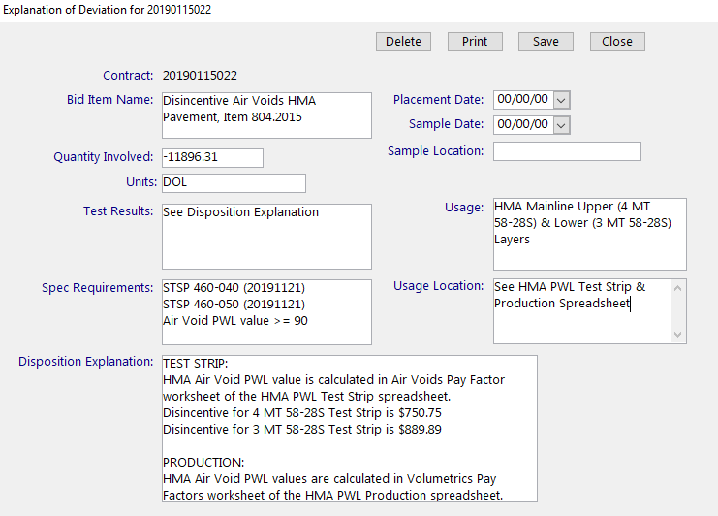
Figure: MIT Entry Disincentive Air Voids HMA Pavement Example

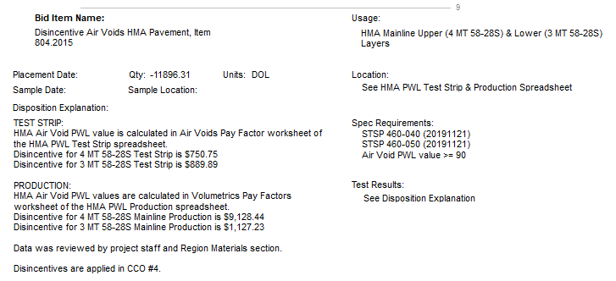
Figure: Printed DT1310 Disincentive Air Voids HMA Pavement Example

